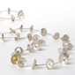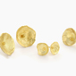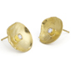

CODE | DESCRIPTION | PRICE
 | DAISY RANGE
DSN1 | Long articulated daisy neckpiece | £410
DSN3 | Double daisy neckpiece | £305
DSP1 | Small 18ct yellow gold daisy pendant + diamond | £285
DSP2 | Small 18ct white gold daisy pendant + diamond | £285
DSP3 | 18ct gold daisy pendant | £210
DSP4 | Single daisy choker | £85
DDP1 | Large double daisy pendant | £145
DDP2 | Medium double daisy pendant | £130
DDP3 | Small double daisy pendant | £100
DSB1 | Long articulated daisy bracelet | £210
DSB2 | Sm long articulated daisy bracelet | £175
DSB3 | Double daisy bracelet | £185
DDR1 | XXL Double daisy ring | £110
DDR2 | XL Double daisy ring | £90
DDR3 | Double daisy ring | £70
DDR4 | Double daisy leaf ring | £70
DSR1 | Large daisy ring | £80
DSR2 | Medium daisy ring | £70
DSR3 | Small daisy ring | £62
DSR4 | Small 18ct gold daisy ring | £255
DDE1 | Double daisy earrings | £50
DDE2 | Double daisy studs | £45
DSE1 | daisy earrings | £45
DSE2 | Large daisy studs | £45
DSE3 | Daisy studs | £42
DSE3 OX | Oxidised daisy studs | £42
DSE4 | 18ct gold daisy studs | £225
DSE5 | Medium 18ct gold daisy studs | £190
DSE6 | Small18ct gold daisy studs | £150
DSE7 | Xs 18ct gold daisy studs | £130
DSDE1 | 18ct gold daisy studs + diamonds – available in white gold | £535
DSDE2 | Medium 18ct gold daisy studs + diamonds – available in white gold | £335
DSDE3 | Small 18ct gold daisy studs + diamonds – available in white gold | £305
DSDE4 | Xs 18ct gold daisy studs + diamonds – available in white gold | £225
DSDE5 | Xs silver daisy studs + diamonds | £110
DSBP1 | Daisy brooch with stalk | £52
DSC | Daisy cufflinks | £45

- WHOLE SALE PRICE LIST

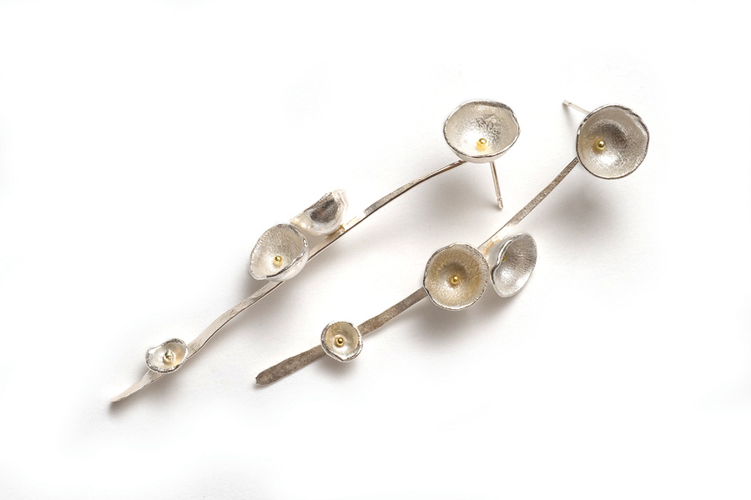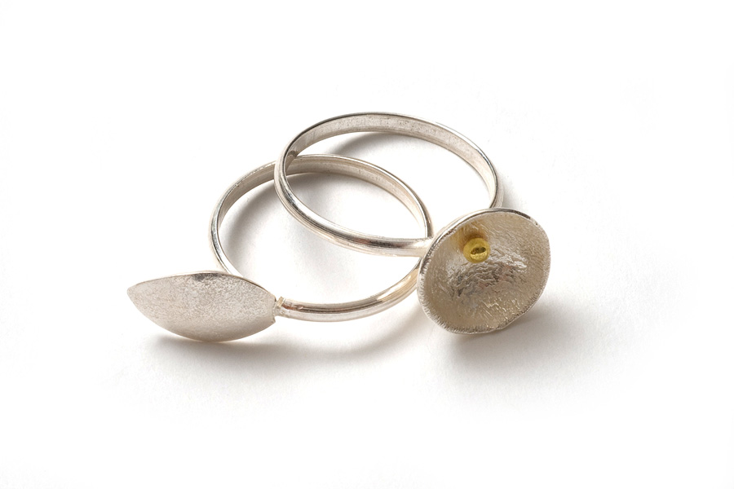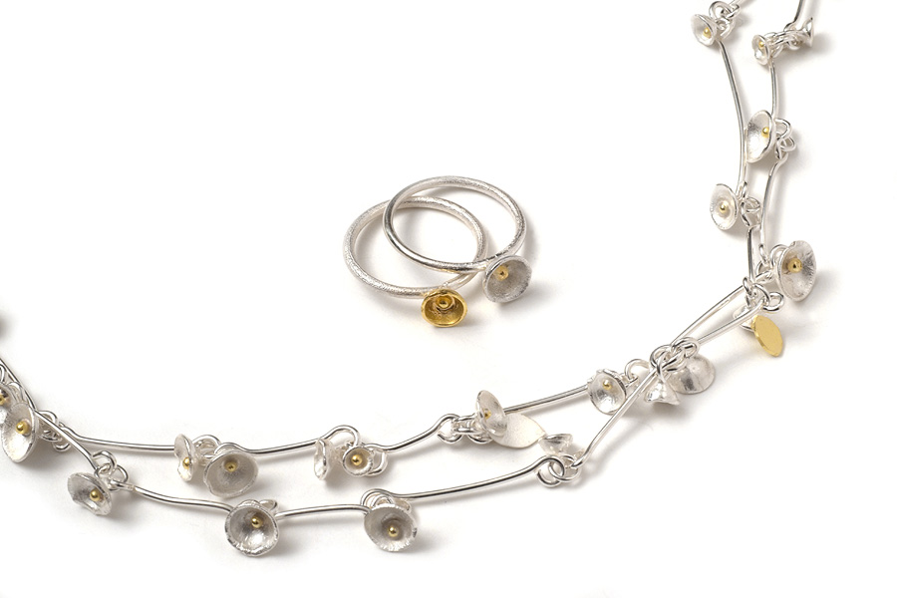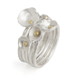

 | ACORN CUP RANGE
ACN1 | Medium acorn cup cluster neckpiece | £590
ACN2 | Small acorn cup cluster neckpiece | £465
ACN3 | 5 Strand Xs acorn cup choker | £145
ACN4 | 3 Strand Xs acorn cup choker | £105
ACB1 | Medium acorn cup cluster bracelet | £210
ACB2 | Short Medium acorn cup cluster bracelet | £100
ACB3 | Small acorn cup cluster bracelet | £180
ACB4 | Short small acorn cup cluster bracelet | £75
ACR1 | Acorn cup leaf ring | £65
ACR2 | Acorn cup leaf ring + stamen | £70
ACR3 | 5 18ct Gold Acorn Cup Rings + Diamonds | £1590
ACR4 | Small 5 18ct Gold Acorn Cup Rings + Diamonds | £1340
ACR5 | 3 18ct Gold Acorn Cup Rings + Diamonds | £1800
ACR6 | Small 3 18ct Gold Acorn Cup Rings + Diamonds | £1025
ACR7 | 5 silver acorn cup rings with diamonds | £900
ACR8 | 5 Acorn Cup Rings | £145
ACR9 | 3 Acorn Cup Rings | £90
ACR10 | Acorn cup cluster ring | £95
ACR11 | Small acorn cup cluster ring + 18ct gold cup | £105
ACR12 | Acorn cup cluster ring, with leaf | £90
ACE1 | Acorn cup earrings | £42
ACE2 | Medium acorn cup cluster earrings | £88
ACE3 | Small acorn cup cluster earrings | £70
ACE4 | Medium acorn cup cluster leaf earrings | £85
ACE5 | Small acorn cup cluster leaf earrings | £75
ACE6 | Medium Acorn Cup Studs- Also available in oxidised silver. | £39
ACE7 | Small Acorn Cup Studs -Also available in oxidised silver. | £37
ACE8 | Extra Small Acorn Cup Studs- Also available in oxidised silver. | £35
ACE9 | XXS Acorn Cup Studs -Also available in oxidised silver. | £32
ACE10 | Large Acorn cup cluster studs | £60
ACE11 | Medium Acorn cup cluster studs | £55
ACE12 | Small Acorn cup cluster studs | £49
ACE13 | Large Acorn cup leaf studs | £49
ACE14 | Medium Acorn cup leaf studs | £45
ACE15 | Small Acorn cup leaf studs | £42
ACBR1 | Large Acorn cup cluster brooch | £70
ACBR2 | Medium Acorn cup cluster brooch | £52
ACBR3 | Small Acorn cup cluster brooch | £42

Shimara Carlow
Studio MG6 Mercator Building Abbotsford Convent 1 St Heliers St Abbotsford Vic 3067 Australia
0458 380 530 shimara@shimara.com www.shimara.com

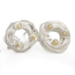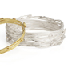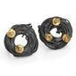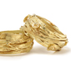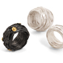

 | SILVER ACORN CUP WRAP RANGE
SACWN1 | 18ct gold wrap choker + acorn cups | £990
SACWN2 | Small oxidised silver wrap choker + 18ct gold acorn cups | £375
SACWN3 | Small silver wrap choker + acorn cups | £175
SACWB1 | 18ct gold wrap bangle + acorn cups | £865
SACWB2 | Silver wrap bangle + 18ct gold acorn cups | £350
SACWB3 | Silver wrap bangle + acorn cups | £170
SACWB4 | Small oxidised silver wrap bangle + 18ct gold acorn cups | £255
SACWB5 | Small silver wrap bangle + acorn cups | £95
SACWR1 | 18ct gold wrap ring + acorn cups | £615
SACWR2 | Large oxidised silver wrap ring + 18ct gold acorn cups | £128
SACWR3 | Oxidised silver wrap ring + 18ct gold acorn cups | £110
SACWR4 | Silver wrap ring + 18ct gold acorn cups | £110
SACWR5 | Large silver wrap ring + acorn cups | £100
SACWR6 | Silver wrap ring + acorn cups | £95
SACWE1 | 18ct gold wrap studs + acorn cups | £285
SACWE2 | Silver wrap studs + 18ct gold acorn cups | £95
SACWE3 | Silver wrap studs + acorn cups | £45
SACWE4 | Oxidised silver wrap studs + 18ct gold acorn cups | £95

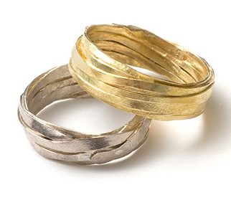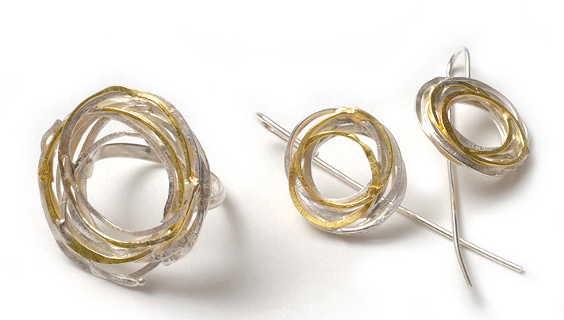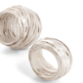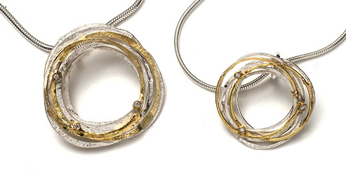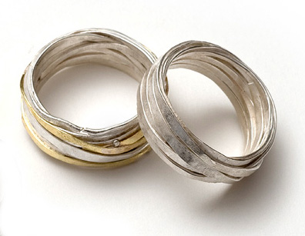

 | SILVER WRAP RANGE
SGWP1 | Large silver and gold wrap pendant + 3 diamonds | £215
SGWP2 | Medium silver + gold wrap pendant + 3 diamonds | £170
SGWP3 | Small silver + gold wrap pendant + diamonds | £115
SGWP4 | Medium silver + gold wrap pendant | £122
SGWP5 | Small silver + gold wrap pendant | £112
SWP1 | Medium silver wrap pendant | £100
SWP2 | Small silver wrap pendant | £85
SWP3 | Medium hammered silver wrap pendant | £95
SWP4 | Small hammered silver wrap pendant | £80
SWB1 | Silver wrap cuff | £240
SWB2 | Gold + silver wrap bangle | £175
SGWR1 | Small silver + gold wrap ring + 3 diamonds | £105
SGWR2 | Medium silver + gold wrap ring | £80
SGWR3 | Medium silver wrap ring | £80
SGWR4 | Small silver wrap ring | £65

Shimara Carlow
Studio MG6 Mercator Building Abbotsford Convent 1 St Heliers St Abbotsford Vic 3067 Australia
0458 380 530 shimara@shimara.com www.shimara.com

 | SILVER WRAP RANGE
SGWR5 | Medium hammered silver wrap ring | £75
SGWR6 | Small hammered silver wrap ring | £60
GWR1 | 1mm 18ct gold wrap ring | £740
GWR2 | 18ct gold wrap ring – also available in white gold | £570
GWR3 | .6mm 18ct gold wrap ring - also available in white gold | £505
GWR4 | .8mm 18ct gold wrap ring - also available in white gold | £395
SWR1 | 1mm Xl silver + gold wrap ring | £105
SWR2 | 1mm Large silver + gold wrap ring | £95
SWR3 | Silver + gold wrap ring | £82
SWR4 | .8mm Silver + gold wrap ring. | £77
SWR5 | 1mm Xl silver wrap ring | £82
SWR6 | 1mm Large silver wrap ring | £70
SWR7 | Large silver wrap ring | £65
SWR8 | Silver wrap ring | £60
SWR9 | Small silver wrap ring | £57
SWR10 | .8mm silver wrap ring | £55
SGWE1 | Silver + gold wrap earrings + diamonds | £160
SGWE2 | Silver +gold wrap earrings | £55
SGWE3 | Silver wrap earrings | £45
SGWE4 | Hammered silver wrap earrings | £40
SGWE5 | Silver + gold wrap studs + diamonds | £160
SGWE6 | Silver + gold wrap studs | £55
SGWE7 | Silver wrap studs | £45
SGWE8 | Hammered silver wrap studs | £40

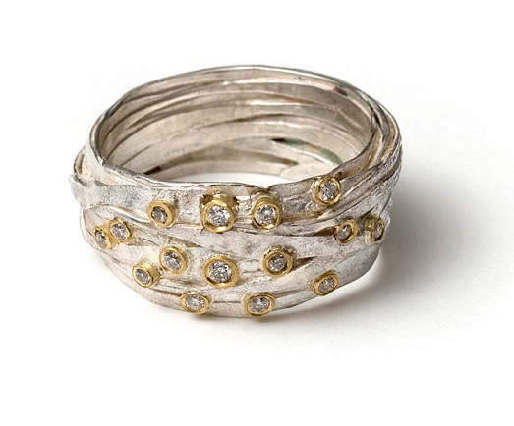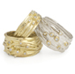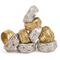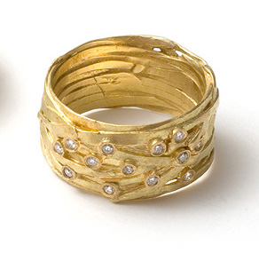

 | WRAP RINGS WITH STONES
WGSR1 | 18ct gold wrap ring + 15 diamonds | £1050
WGSR2 | 18ct gold wrap ring + 12 diamonds | £1020
WGSR3 | Large 18ct gold wrap ring + tall tube + 9 mixed diamonds | £1260
WGSR4 | 18ct gold wrap ring in tall settings with 9 mixed diamonds | £1000
WGSR5 | 18ct gold wrap ring + tall tube + 7 mixed diamonds | £825
WGSR6 | 18ct gold wrap ring + 7 small mixed diamonds | £575
WGSR7 | 18ct gold wrap ring + 6 diamonds | £815
WGSR8 | 18ct gold wrap ring + 6 pink sapphire | £565
WGSR9 | 18ct gold wrap ring + 6 aqua marine | £565
WSR1 | Large silver wrap ring + 15 diamonds | £680
WSR2 | Silver wrap ring + 15 diamonds | £590
WSR3 | Large silver wrap ring + 9 mixed diamonds | £590

Shimara Carlow
Studio MG6 Mercator Building Abbotsford Convent 1 St Heliers St Abbotsford Vic 3067 Australia
0458 380 530 shimara@shimara.com www.shimara.com

 | WRAP RINGS WITH STONES
WSR4 | Silver wrap ring + 9 mixed diamonds | £475
WSR5 | Silver wrap ring + tall gold tube + 7 mixed diamonds | £420
WSR6 | Silver wrap ring + tall gold tube + 7 sm mixed diamonds | £285
WSR7 | Silver wrap ring, gold tube + 5 diamonds 2.4mm | £370
WSR8 | Silver wrap ring, gold tube + 5 diamonds 2.2mm | £305
WSR9 | Silver wrap ring, gold tube + 5 pink sapphire 2.2mm | £230
WSR10 | Silver wrap ring, gold tube + 5 aquamarine 2.2mm | £230

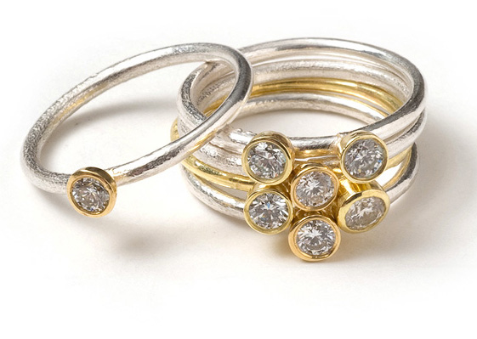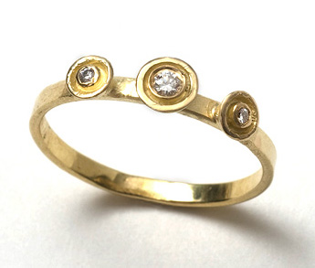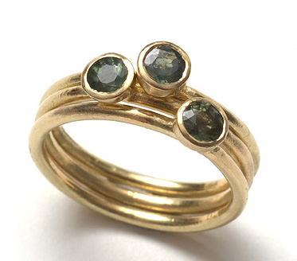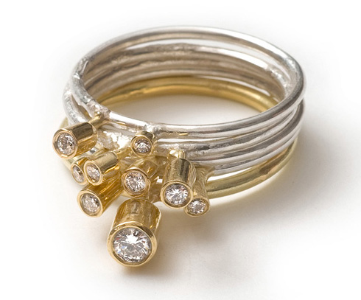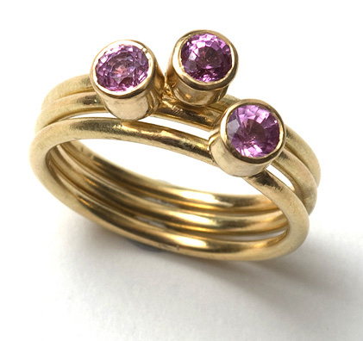

 | RING SETS WITH STONES
SRS1 | 6 18ct gold gum nut rings with pink sapphire and greet tourmaline | £1130
SRS2 | 3 18ct gold gum nut rings with diamonds | £1090
SRS3 | 5 silver + 18ct gold gum nut rings + 7 diamonds | £1315
SRS4 | 5 tall silver + 18ct gold gum nut rings + mixed diamonds | £735
SRS5 | 5 silver + 18ct gold cup rings + diamonds | £785
SRS6 | 5 small silver + 18ct gold cup rings + diamonds | £635
SRS7 | 5 silver cup rings + diamonds | £305
SRS8 | 5 small silver cup rings + diamonds | £235
SRS9 | 3 18ct gold bands with 3 diamonds | £450
SRS10 | 3 silver cup rings + aqua marine | £155
SRS11 | 18ct gold tall gum nut solitaire ring | £450
SRS12 | 18ct gold square wedding ring, to match above | £270
SRS13 | 18ct gold d section men’s wedding ring | £465
SES1 | 18ct yellow gold gum nut studs + diamonds | £365
SES2 | 18ct white gold gum nut studs + diamonds | £365

Shimara Carlow
Studio MG6 Mercator Building Abbotsford Convent 1 St Heliers St Abbotsford Vic 3067 Australia
0458 380 530 shimara@shimara.com www.shimara.com

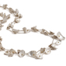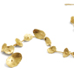

 | HONESTY RANGE
HN1 | 18ct gold honesty neckpiece | £3650
HN2 | Large honesty neckpiece + 18ct gold | £1525
HN3 | Large long honesty neckpiece | £905
HN4 | Large honesty neckpiece | £605
HN5 | Large short honesty neckpiece | £350
HN6 | Medium long honesty neckpiece | £565
HN7 | Medium honesty neckpiece | £425
HN8 | Small long honesty neckpiece | £380
HN9 | Small honesty neckpiece | £325
HP1 | 18ct gold honesty pendant | £215
HP2 | Large honesty pendant | £105
HP3 | Medium honesty pendant | £95
HP4 | Small honesty pendant | £85
HB1 | 18ct gold honesty bracelet | £1465
HB2 | Large honesty bracelet + 18ct gold | £410
HB3 | Large long honesty bracelet | £255
HB4 | Large articulated honesty bracelet | £110
HB5 | Medium long honesty bracelet | £195
HB6 | Medium honesty bracelet | £105
HB7 | Small long honesty bracelet | £145
HB8 | Small honesty bracelet | £100
HR1 | Medium 18ct gold honesty ring | £255
HR2 | Small 18ct gold honesty ring | £225
HR3 | XX Large honesty ring | £120
HR4 | Extra Large honesty ring | £110
HR5 | Large honesty ring | £100
HR6 | Medium honesty ring | £80
HR7 | Small honesty ring | £65
HE1 | Large honesty earrings | £55
HE2 | Medium honesty earrings | £50
HE3 | Small honesty earrings | £42
HE4 | Extra Small honesty earrings | £35
HE5 | Medium 18ct gold honesty studs | £210
HE6 | Small 18ct gold honesty studs | £150
HE7 | Large honesty studs | £45
HE8 | Medium honesty studs | £42
HE9 | Small honesty studs | £35
HE10 | Extra Small honesty studs | £32
HBR1 | Extra Large honesty brooch | £100
HBR2 | Large honesty brooch | £65
HBR3 | Medium honesty brooch | £52

Shimara Carlow
Studio MG6 Mercator Building Abbotsford Convent 1 St Heliers St Abbotsford Vic 3067 Australia
0458 380 530 shimara@shimara.com www.shimara.com

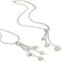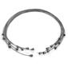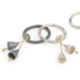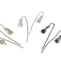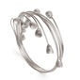
 | GUM NUT RANGE
GNN1 | Silver bell gum nut wrap choker + 18ct gold | £260
GNN2 | Oxidised silver bell gum nut wrap choker + 18ct gold | £260
GNN3 | Silver bell gum nut wrap choker | £225
GNP1 | 5 pod gum nut pendant + 18ct gold | £145
GNP2 | 3 Pod Gum Nut Pendant + 18ct Gold | £120
GNP3 | 3 Pod Gum Nut Pendant | £110
GNP4 | 3 bell Gum Nut Pendant + 18ct Gold | £115
GNP5 | Oxidised 3 bell Gum Nut Pendant + 18ct Gold | £115
GNP6 | 3 bell Gum Nut Pendant | £92
GNB1 | Silver Bell Gum Nut Wrap Bangle with 18ct gold | £225
GNB2 | Oxidised Silver Bell Gum Nut Wrap Bangle with 18ct gold | £225
GNB3 | Silver Bell Gum Nut Wrap Bangle | £185
GNR1 | 2 Bell Gum Nut Ring + 18ct Gold detail | £65
GNR2 | Oxidised 2 Bell Gum Nut Ring + 18ct Gold detail | £65
GNR3 | 2 Bell Gum Nut Ring | £55
GNR4 | Large Bell Gum Nut Ring + 18ct Gold detail | £65
GNR5 | Oxidised Large Bell Gum Nut Ring + 18ct Gold detail | £65
GNR6 | Large Bell Gum Nut Ring | £55
GNR7 | 3 Bell Gum Nut Rings + 18ct Gold detail | £115
GNR8 | Oxidised 3 Bell Gum Nut Rings + 18ct Gold detail | £115
GNE1 | Medium Pod Gum Nut Earrings with 18ct gold | £60
GNE2 | Medium Bell Gum Nut Earrings with 18ct gold | £60
GNE3 | Bell Gum Nut Earrings with 18ct gold | £50
GNE4 | Oxidised Bell Gum Nut Earrings with 18ct gold | £50
GNE5 | Bell Gum Nut Earrings | £42
GN1 | 3 Medium silver pod gum nut brooch + 18ct gold | £100
GN2 | 3 Small silver pod gum nut brooch + 18ct gold | £60
GN3 | 3 Small silver pod gum nut brooch | £50

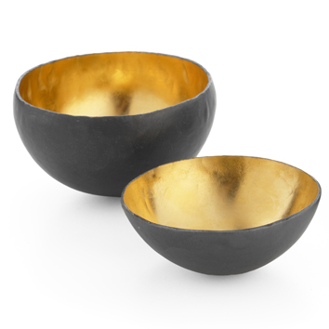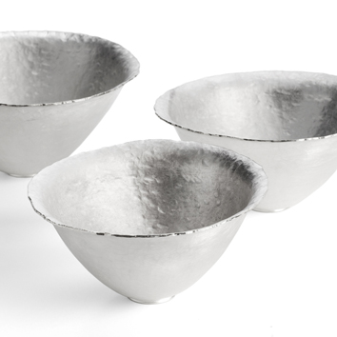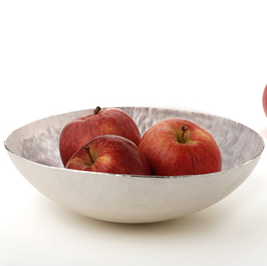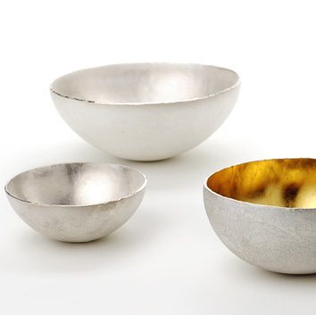

 | BOWLS
FSD1 | Large fine silver dish | £865
FSB1 | Large fine silver bowl | £695
FSB2 | Medium fine silver bowl | £595
FSB3 | Small fine silver bowl | £275
FSB4 | Extra small fine silver bowl | £175
FSGB1 | Medium fine silver bowl + gold plate | £620
FSGB2 | Small fine silver bowl + gold plate | £290

Shimara Carlow
Studio MG6 Mercator Building Abbotsford Convent 1 St Heliers St Abbotsford Vic 3067 Australia
0458 380 530 shimara@shimara.com www.shimara.com

 | BOWLS
FSGB3 | Oxidised small fine silver bowl + gold plate | £290
FSGB4 | Extra small fine silver bowl + gold plate | £200
FSGB5 | Oxidised extra small fine silver bowl + gold plate | £200
FSCB1 | Fine silver conserve pot with gum nut spoon + gold plate | £780
FSMB1 | Fine silver mustard pot with gum nut spoon + gold plate | £365

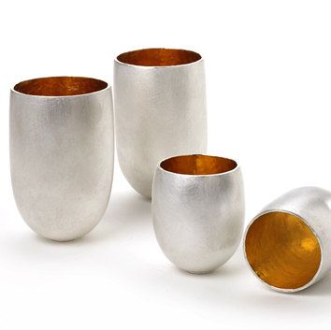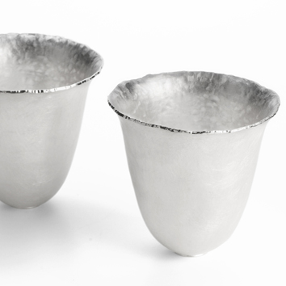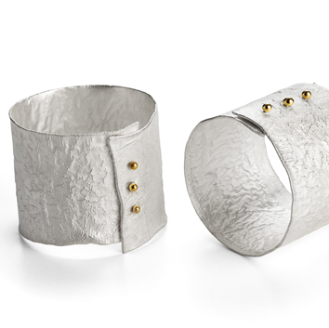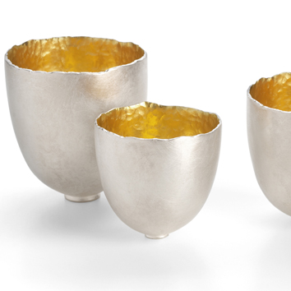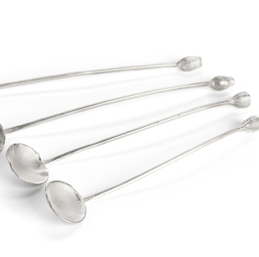

 | SILVERSMITHING
FST1 | Large fine silver fluted tumbler | £620
FST2 | Fine silver fluted tumbler | £510
FSTG1 | Tall fine silver tumbler + gold plate | £530
FSSG1 | Large fine silver Saki cup + gold plate | £430
FSSG2 | Medium fine silver Saki cup + gold plate | £320
FSSG3 | Small fine silver Saki cup + gold plate | £295
FSSG4 | Extra Small fine silver Saki cup + gold plate | £220
FSSG5 | Tall fine silver shot + gold plate | £335
FSSG6 | Pod fine silver shot + gold plate | £335
FSS1 | Tall fine silver shot | £300
FSS2 | Pod fine silver shot | £300
FSS3 | Small egg shell shot | £160
SNR1 | Reticulated napkin ring + 18ct gold | £115
SS1 | Caddy spoon with gum nut handle + 18ct gold | £130
SS2 | Long oval spoon with gum nut handle + 18ct gold | £100
SSS1 | Silver gum nut salt spoon with oval bowl | £42
SSS2 | Silver gum nut salt spoon | £42

TERMS AND CONDITIONS

Initial order £250 pro forma, thereafter 30 days.
Please allow 6-8 weeks delivery.
Please note silversmithing items may take longer.
All orders are sent registered mail, insured p + p cost £12.50.
Claims for damages or shortages must be made verbally on receipt, and in writing within 5 working days.
All good remain the property of Shimara Carlow until paid in full.

All Items are made from sterling silver unless otherwise stated. All gold is 18ct gold; all gold plate is 23 1/2ct gold

Shimara Carlow
Studio MG6 Mercator Building Abbotsford Convent 1 St Heliers St Abbotsford Vic 3067 Australia
0458 380 530 shimara@shimara.com www.shimara.com

